# 畫面設計

## 查詢主畫面

ffefefefefef  
fefefefefefefeffe

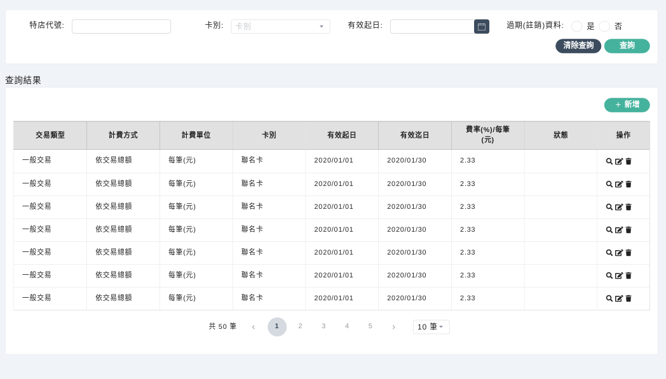

fefefefe  
feffeff

|  |  |  |
| --- | --- | --- |
| grgrgff ffffffffffffff ffffffffffffff ffffffffffffffff ffffffffffffffffffffffffffffffffffffffffffff | N/A | N/A |
| grgrg | N/A | N/A |
| grgrg | N/A | N/A |
| grgrg | N/A | N/A |
| grgrg | N/A | N/A |
| grgrg | N/A | N/A |

|  |
| --- |
| grgrgr |